**3.2.1 Trace Table**

|  |  |  |  |  |  |  |  |  |  |
| --- | --- | --- | --- | --- | --- | --- | --- | --- | --- |
|  | dist | dollarsPerL | mpg | maxKPH | dollars at 100 | dollars at 120 | drive at 100 | drive at 120 | Time difference |
| Trace 1 | 25 | 1.22 | 2.2 | 0.97 | 32.39 | 38.67 | 15.0 | 12.5 | 2.5 |
| Trace 2 | 30 | 1.10 | 22 | 0.97 | 3.5 | 4.18 | 18.0 | 15.0 | 3.0 |

**3.2.1 Manual Calculation Trace 1:**

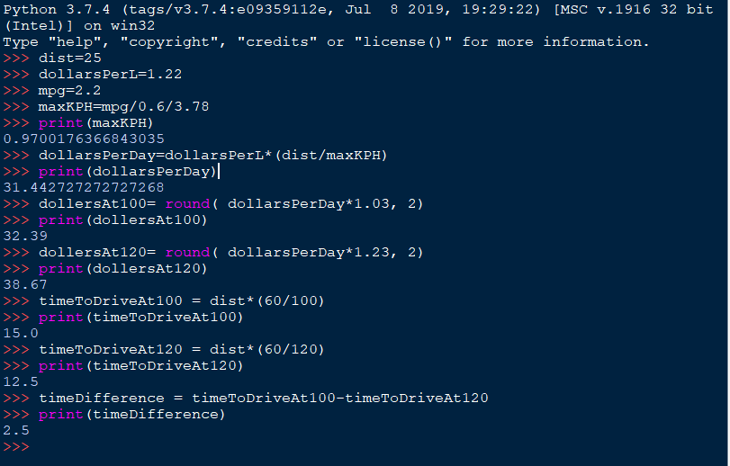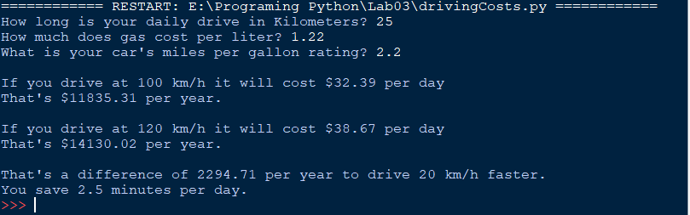

**Trace 2:**

